



adges UI components library

**Component ID #1 – ex-timeline - v1.0.0**

## Document Control

## Version History

|  |  |  |  |
| --- | --- | --- | --- |
| Version | Date | Author | Reason for Change |
| **1.0.0** | 2/14/2020 |  |  |
| **1.1.0** | 09/24/2020 | Rijin Mukundan |  |
|  |  |  |  |
|  |  |  |  |
|  |  |  |  |
|  |  |  |  |
|  |  |  |  |
|  |  |  |  |

## Review History

|  |  |  |
| --- | --- | --- |
| Version | Reviewer | Date |
|  |  |  |
|  |  |  |
|  |  |  |
|  |  |  |
|  |  |  |
|  |  |  |
|  |  |  |

Table of Contents

Document Control 2

Version History 2

Review History 2

1. Document and components Purpose. 4
2. General Information. 4
3. How to use. 5
4. Component features and configure. 6
5. How to configure component. 7
6. Examples 7

# 

# Document and components Purpose.

The purpose of the document is to guide how use and configure timeline component.

# General Information.

Component Name: Timeline.

Extension Theme: ex-timeline.

Owner: .

Version no: v1.0.0

Design

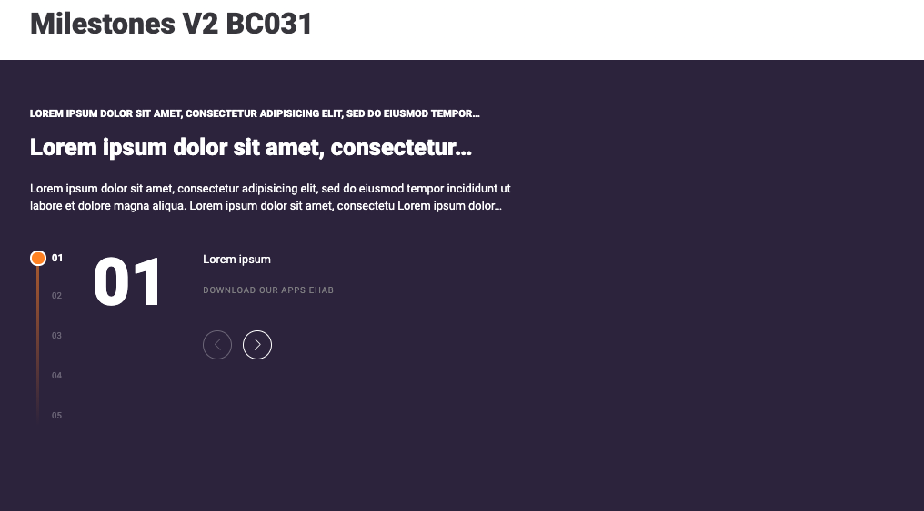

# How to use.

1. The available commands for this project .
   1. Compile : npm run gulp compile -- –path ex-timeline –extension
   2. Compile & include under ADGE tenant : npm run gulp compile -- –path ex-timeline –extension –full –dest [ADGEFolder]
   3. Deploy : npm run gulp deploy -- –path ex-timeline –extension
2. *Now project have full copy from this extension theme under the project theme and you can apply the project brand guideline and configure component based on project needs.*

# Component features and configure.

You have access now to configure component with the below item.

$timeline-background : #322746 !default;

$timeline-height: 650px !default;

$timeline-container-padding-right : 48px !default;

$timeline-wrapper-height : 220px !default;

$timeline-wrapper-margin : 40px auto !default;

$timeline-wrapper-line-opacity : 0.6 !default;

$timeline-wrapper-line-background-first : $primary-color !default;

$timeline-wrapper-line-background-second : color-opacity($timeline-background , 0.2) !default;

$timeline-wrapper-line-width : 4px !default;

$timeline-navigator-width : 75px !default;

$timeline-navigator-item-displayed : 5 !default;

$timeline-navigator-item-color : $white-color !default;

$timeline-navigator-item-color-hover : $white-color !default;

$timeline-navigator-item-opacity : 0.3 !default;

$timeline-navigator-item-margin-top : 2px !default;

$timeline-navigator-item-selected-margin-top : 4px !default;

$timeline-navigator-item-fontsize : 12px !default;

$timeline-navigator-item-fontsize-hover :14px !default;

$timeline-navigator-item-padding-left : 20px !default;

$timeline-navigator-item-bullet-size: 15px !default;

$timeline-navigator-item-bullet-seleced-size : 22px !default;

$timeline-navigator-item-bullet-radius : 50% !default;

$timeline-navigator-item-bullet-background : $white-color !default;

$timeline-navigator-item-bullet-border-color : $primary-color !default;

$timeline-navigator-item-bullet-background-selected : $primary-color !default;

$timeline-navigator-item-bullet-border-color-selectd : $white-color !default;

$timeline-navigator-item-bullet-border-size : 3px !default;

$timeline-navigator-item-bullet-border-size-selected: 3px !default;

$timeline-content-label-color: $white-color !default;

$timeline-content-label-fontsize: 90px !default;

$timeline-content-label-lineheight: 90px !default;

$timeline-content-label-margin-right: 48px !default;

$timeline-content-text-color:$white-color !default;

$timeline-title-margin-right : 70px !default;

$timeline-arrows-color : $white-color !default;

$timeline-arrows-color-hover : $white-color !default;

$timeline-arrows-button-size: 40px !default;

$timeline-arrows-button-background: $primary-color !default;

$timeline-arrows-button-border-color : $white-color !default;

$timeline-arrows-button-border-size : 1px !default;

$timeline-arrows-button-margin : 15px !default;

$timeline-image-wrapper-width : 40% !default;

$timeline-image-wrapper-pattern-width : 180px !default;

$timeline-image-wrapper-pattern-overlay-color: #000 !default;

# How to configure component.

There are various ways to configure the component:

1. **CSS Class / Data Configuration (on the variant)**

**Data Attribute Modifiers**

These attributes can be applied in the variant to get the desired result

|  |  |  |
| --- | --- | --- |
| Feature | Modifier | Default value |
| Orientation of the timeline | data-orientation | expanded |
| Set starting index of the timeline | data-startindex |  |
| Set arrow key property for the plugin | data-arrowkeys |  |
| Speed at which the timeline slides | data-contentsspeed |  |
| Navigator speed | data-navigatorsspeed |  |

1. **Adding Built-In or Bootstrap Class (on the variant)**
   1. Spaces, Font weights, Display, Position properties etc can be added by bootstrap classes
      1. i. Spacing: <https://getbootstrap.com/docs/4.0/utilities/spacing/>
      2. ii. Flex: <https://getbootstrap.com/docs/4.4/utilities/flex/>
      3. iii. Font: <https://getbootstrap.com/docs/4.0/content/typography/>
   2. These classes should only be added to match the design
   3. For built-in classes check 7 Below to see the entire list
2. **SCSS Variable Override (on the _override.scss file)**

To configure the component we can take the above variables from section **4. Component features and configure** and add them to: adge-ph2/themes/<ADGE>/vars/_override.scss, this file with your desired changes to match the design.

1. **Complete style override**
   1. This should be the last and final option if the above 3 didn’t get you the desired output
   2. This is overwriting the SCSS of the component by adding your own style to it
   3. **Note: Take permission before doing this override**
   4. Instructions:
      1. Open the file /adge-ph2/themes/<ADGE>/sass/overrides.scss and add your own SCSS styles to override the faulty component.

# Dependencies

* components-timeline.css
* jquery.txtTruncate-min.js
* truncate-init.js
* jquery.timelinr-0.9.7.js
* components-timeline.js

# Examples

Examples1:

I need to change text color.

I’ll copy the below variables from extension theme.

$highlight-main-tittle-color: $primary-color;

Then will paste the above variable in project folder theme in file _custom.scss and change with any variable based on site needs.

$highlight-main-tittle-color: $secondary-color;

Examples2:

I need to the button shape from square to had a rounded corner.  
I’ll copy the below variables from extension theme.

$button-shape-square: $border-radius-value;

$border-radius-value: 0px;

Then will paste the a above variable in project folder theme in file _custom.scss and change with any variable based on site needs.

$button-shape-square: $border-radius-value;

$border-radius-value: 20px;